**Aneesh Pavan Prodduturu**

**Q: How do I create a cube/box only with a grid in Houdini SideFX?**

**A:** Firstly, open The Houdini Apprentice.



This interface consists of three panes: the Viewers pane, the Parameters pane, and the Network pane.

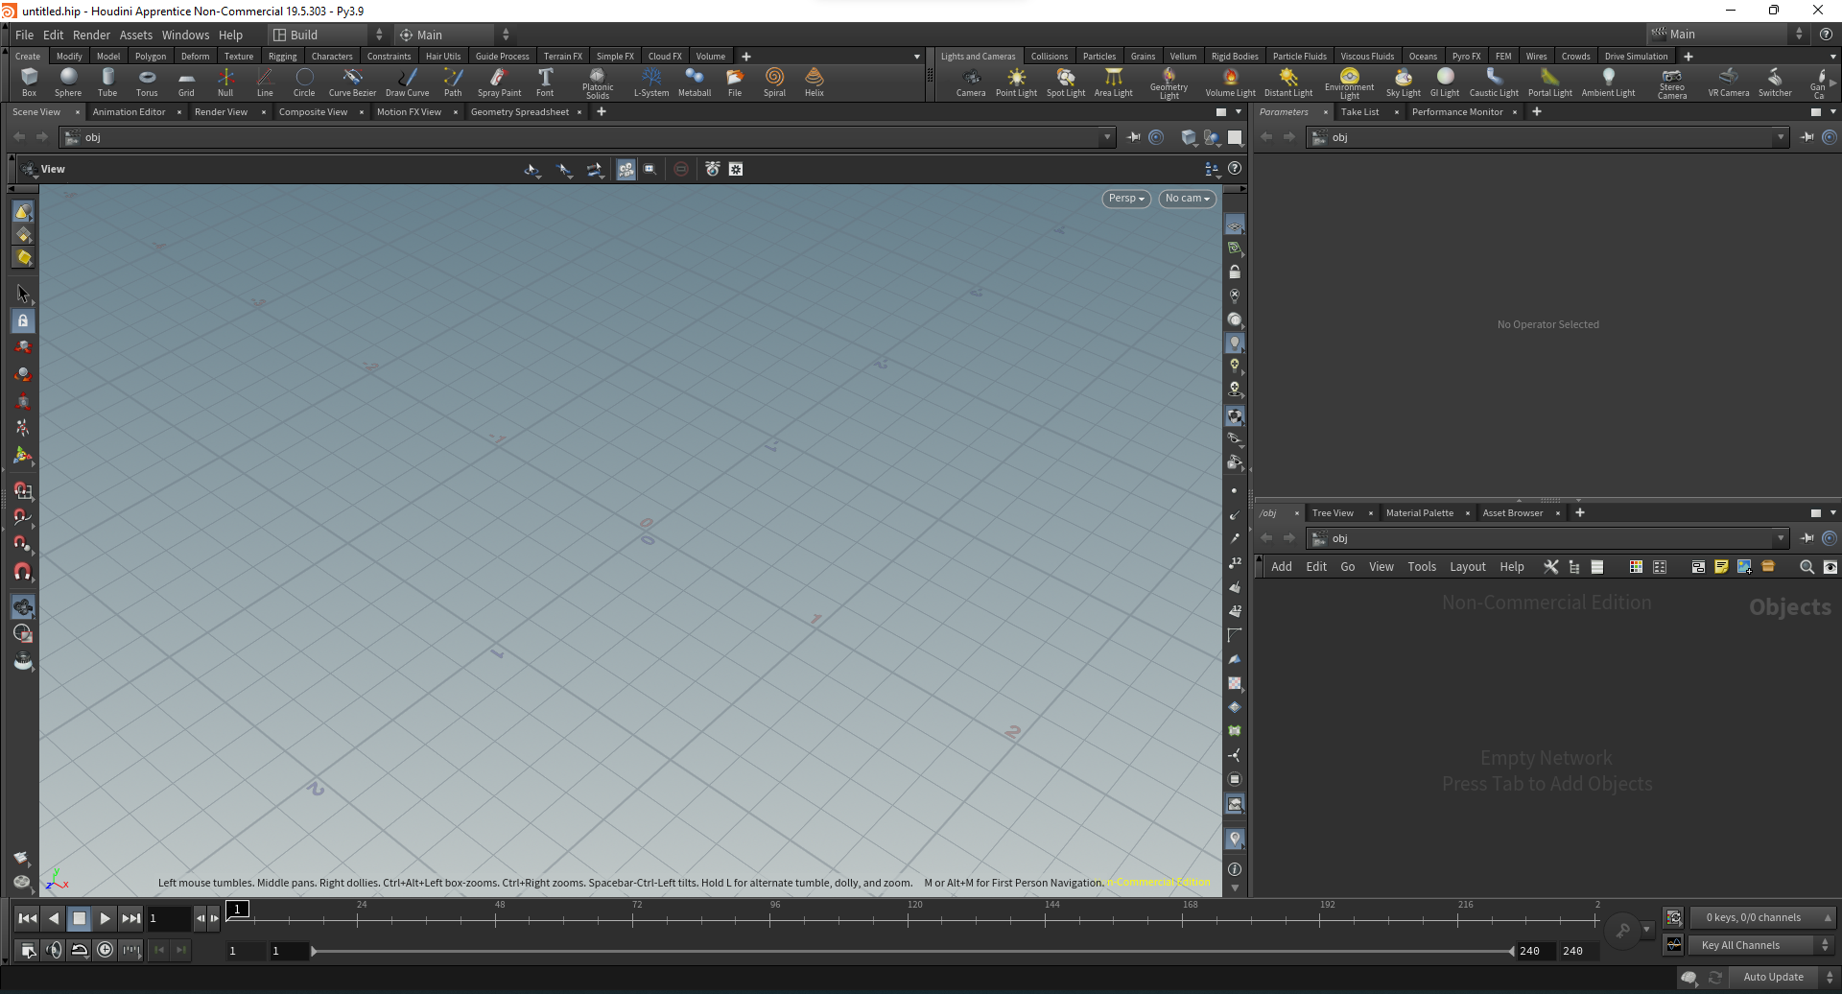

To get started, we first need to change the network pane from objects to geometry by right-clicking, adding geometry in the pane, and double-clicking on the node to turn the pane into geometry.



Add a grid in the network pane

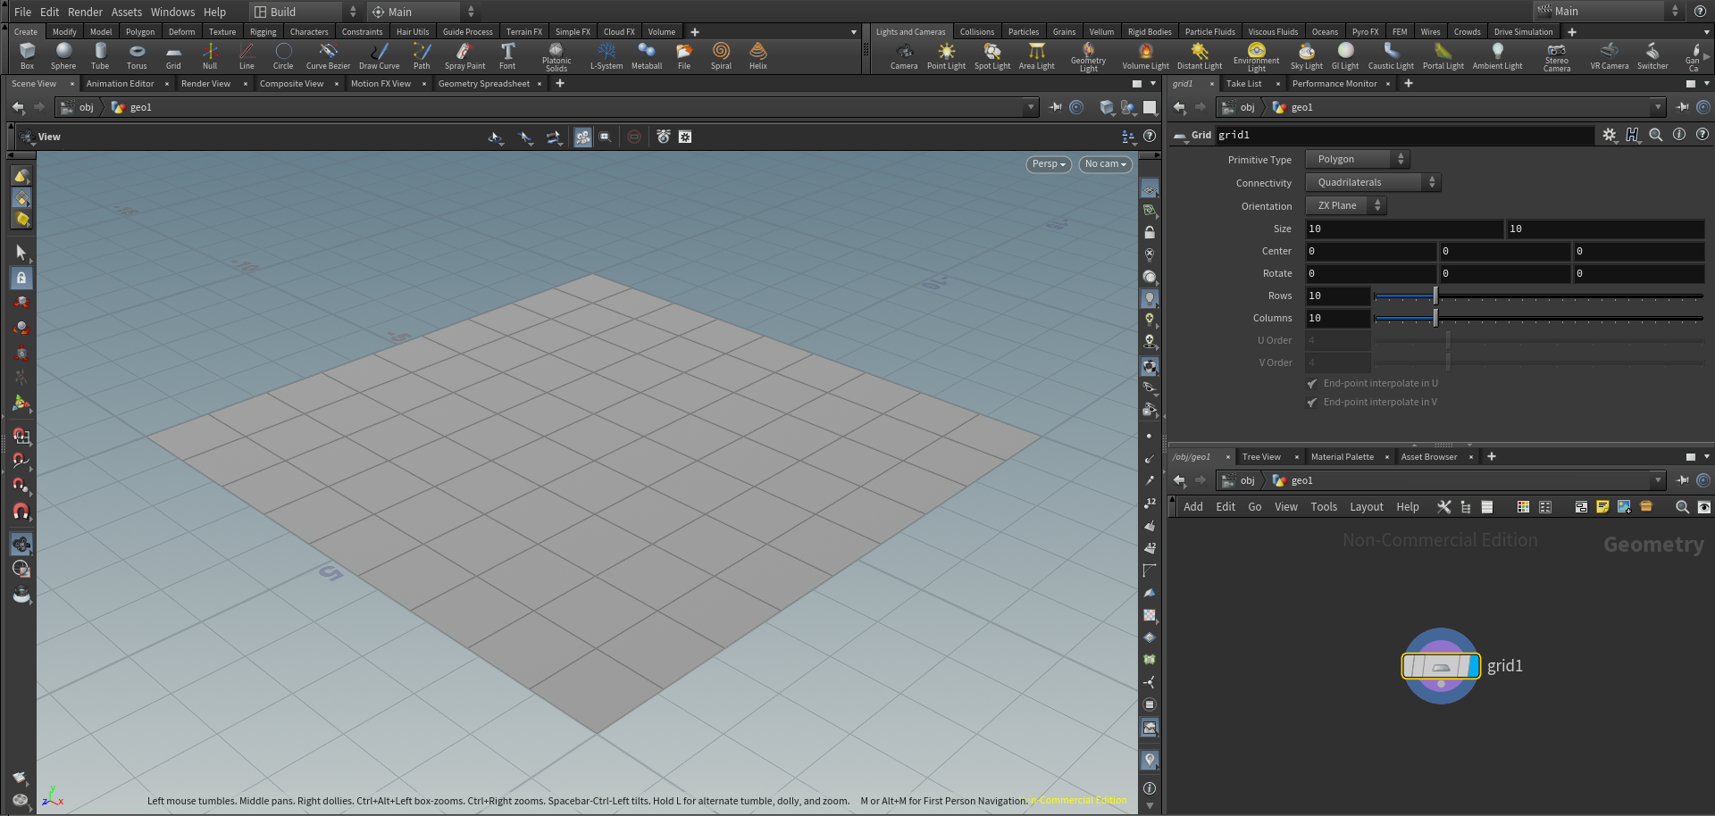

Add polyextrude to add the height of the grid, which makes it look like a cube.

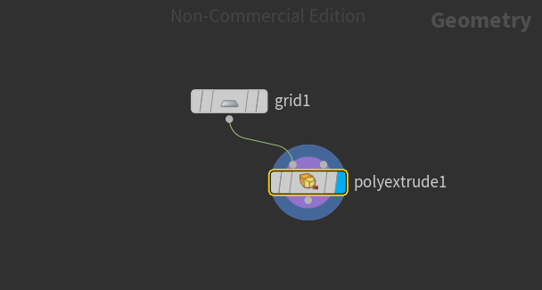

The final image looks like this when grid rows and columns are reduced to 2 and divisions in polyextrude to 1.

